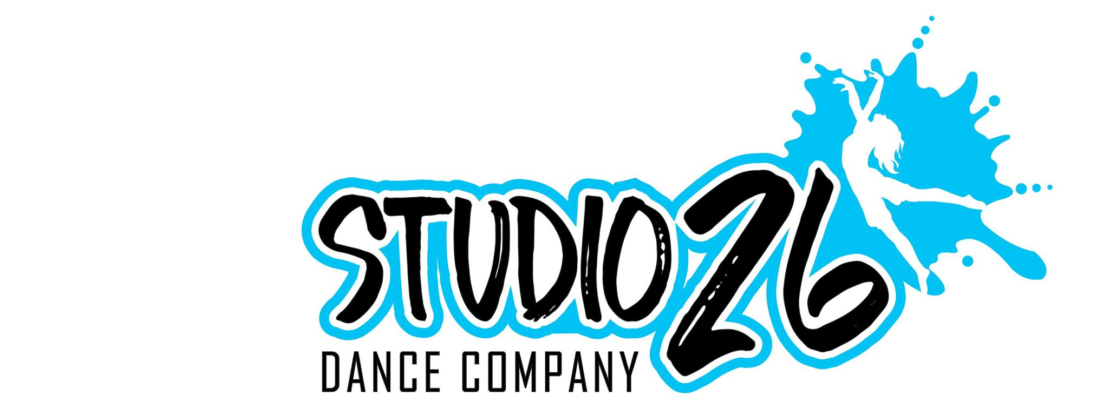STUDIO 26 DANCE COMPANY
SUMMER CAMP 2019 REGISTRATION FORM

Date______________________

Parent/Guardian: ____________________________________________________
Relationship to Student: ______________________________________________
Home Phone: _________________________ Cell: _________________________
Work: _____________________ Email: __________________________________
Address: ___________________________________________________________
Student’s Full Name: _________________________________________________
Student’s Date of Birth (mm/dd/yy) _____ _____ _____ Age:_____________ Grade____

DOES THE STUDENT HAVE ANY ALLERGIES, HEALTH PROBLEMS OR SPECIAL NEEDS? IF SO, PLEASE SPECIFY.
_____________________________________________________ NO__________
Emergency Contact
Name: _____________________________________________________________
Relationship:__________________________ Phone:________________________

Liability Waiver
I, _______________________________________________________, parent/guardian of ___________________________________, hereby release and discharge Studio 26 Dance Academy and its officers, agents, employees, volunteers and affiliates from any and all liability arising from any personal injury, including death, damage to property, or any other loss, which has or may in the future accrue, to _______________________________ on account of participating in any Studio 26 Dance Academy program or activity.

Signature of Parent/Guardian ____________________________________________________
Date _______________________________________________________________________

Refund Policy
Once registration fees have been paid, there will be no refunds for any reason. However, fee transfers may be permitted in exceptional circumstances, as outlined in the Studio 26 Dance Academy Policies and Procedures. I understand the above and agree not to receive a refund.

Signature of Parent/Guardian ____________________________________________________
Date _______________________________________________________________________

Photo/Video Release
I understand and accept that any photo, video, recording, or any other media captured by or on behalf of Studio 26 Dance Academy during classes, rehearsals, photo shoots, performances, or events are and shall remain the sole property of Studio 26 Dance Academy and may be used without compensation to those captured for promotional, educational, commercial, or instructional purposes. I understand the above and to the use of such materials.

Signature of Parent/Guardian ____________________________________________________
Date _______________________________________________________________________

